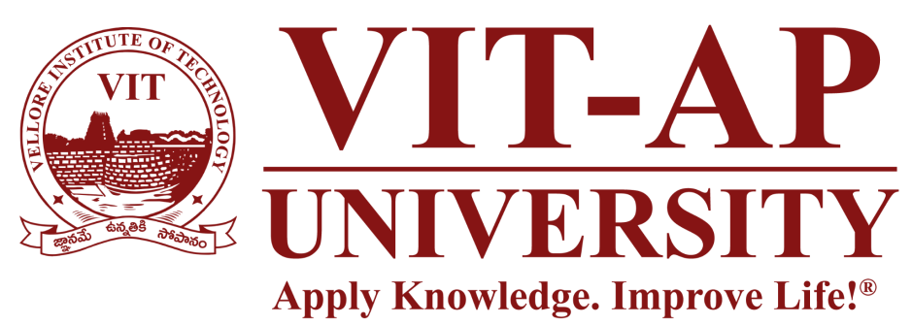

First Review

Project Title:-
SkyWrite In The Wind Using Python And OpenCv

Course: Summer Internship Project (22 Batch MTCSE & MTSE) Presented by: 1) G. Thulasidhar Reddy [Reg. No. 22MIC7099]
2) V. Jaya Chandra [Reg. No. 22MIC7215]
3) K. Vishwesh Aryan [Reg. No. 22MIC7109]

Project Guide: Prof: A. Padma

Project Objectives

- Our goal is to create a system that lets a user draw on a screen in real-time just by moving their hand. We're using a standard webcam, which makes the project accessible to anyone. The core of the project is using the Mediapipe library for highly accurate hand and fingertip detection, while OpenCV will handle all the video processing and drawing. We also plan to build a simple user interface for basic functions like choosing colors and clearing the canvas.

System Design and Architecture

We've finalized the project's architecture to ensure it runs smoothly in real-time.

- Input Layer: The system's only input is the live video feed from a standard webcam.
- Processing Core: For every frame of video, the system performs a sequence of tasks:
  - Hand Landmark Detection: We use Mediapipe to process the frame and identify the 21 key points, or "landmarks," of the hand.
  - Gesture Analysis: Our Python code checks the position of these landmarks to figure out what the user wants to do. For example, one finger up means "draw," while two fingers up means "select a tool."
  - Coordinate Tracking: When in drawing mode, the code records the (x, y) coordinates of the index fingertip.
- Output Layer: The tracked coordinates are then used by OpenCV to draw lines on a separate "Paint" window, creating a visual path of the finger's movement.

Progress and Implementation Status

We've made significant progress since the zeroth review and have completed the initial implementation.
- Environment Setup: Our development environment is fully configured with Python, OpenCV, Mediapipe, and NumPy.
- Core Functionality Achieved:
  - The system can successfully access the webcam, capture video, and display it on the screen.
  - Basic hand tracking is working. Mediapipe correctly identifies the hand landmarks in real-time.
  - The primary drawing feature is operational. The app can track the index finger and draw a single-color line on the canvas.
  - A basic User Interface (UI) with buttons for different colors and a "Clear" function has been created.
- Challenges Faced: We ran into some initial challenges with library compatibility, which required us to standardize our Python version. We also spent time fine-tuning the gesture detection logic to prevent accidental drawing

Next Steps

Our focus for the next phase includes:
- Improving the drawing algorithm to create smoother, more natural-looking lines.
- Enhancing the user interface with more professional features and better visual feedback for the selected tool.
- Implementing advanced drawing tools, such as the ability to draw perfect shapes like rectangles and circles.

THANKYOU.

